Earth Science Test #1

Introduction and Topographic Maps

Answer the following multiple choice questions by circling the correct answer on the appropriate answer sheet. DO NOT WRITE on this test.

--------------------------------------------------------------------------------------

E
A

A
B F

C G
BM 7000

D
H

1. | On the above topographic map, which symbol represents a house? | a. A  b. E  c. F  d. G  e. H
2 | On the above topographic map, the symbol labeled with an H is a | a. school  b. church  c. cemetery  d. factory  e. court house
3 | On the above topographic map, what would you expect to find if you went to the symbol labeled B? | a. gravel  b. mine shaft  c. two shovels  d. construction site  e. crossed spears
4 | The area enclosed by the dashed-dotted line would most likely be colored with what color? | a. green  b. purple  c. pink  d. brown  e. blue
5. | The object labeled C in the above map would most likely be colored with what color? | a. green  b. purple  c. pink  d. brown  e. blue
6 | If the contour interval on the above topographic map is 50 feet, what is the approximate elevation of the school? | a. 7025’  b. 7125’  c. 7200’  d. 7250’  e. 8000’
7 | The line labeled D would be printed in what color on a typical topographic map? | a. pink  b. brown  c. orange  d. green  e. purple  f. blue
8 | If you went to the location labeled A on the above topographic map, which of the following signs might you see posted there? | a. Danger! Building ready to collapse  b. Danger! Abandoned silo – Do not try to climb.  c. Do Not Enter! Restricted Area – Unexploded artillery shells.  d. Danger! Abandoned mine  e. Caution! Low-flying aircraft in the immediate area
9 | What is the approximate population of the town shown on the above map if the average family size is 3 and only one family occupied a single house? | a. 12  b. 24  c. 36  d. 48  e. 60
10 | What does 1:24,000 mean? | a. 1” in real life equals  24,000 feet on the map  b. 1” in real life equals  24,000 inches on the map  c. 1” on the map equals  24,000 feet in real life  d. 1cm on the map equals  24,000 cm in real life  e. none of the above
11 | What is the typical size of a topographic map? | a. 7.5’  b. 7.5º  c. 15º  d. a & c  e. b & c
12 | What does C.I. mean with respect to topographic maps? | a. Criminal Investigration  b. Central Inteligence  c. control interval  d. contour interval  e. cultivation interval
13 | On a topographic map, what does the symbol to the right represent? | a. construction area  b. cemetary  c. athletic field  d. church parking lot  e. football field
14 | On a topographic map, what does the symbol to the right represent?  black in color | a. intermittent stream  b. boundary line  c. intermittent road  d. dirt road  e. trail
15 | When numbering sections within a township, you start with the section in the | a. uppermost left  b. lowermost left  c. uppermost right  d. lowermost right  e. center and spiral outwards  f. varies with township
16 | A township consists of how many sections? | a. 12  b. 24  c. 36  d. 48  e. varies from township to  township
17 | On a topographic map, what color are new additions to a map after it has been published? | a. pink  b. brown  c. orange  d. green  e. purple  f. blue
18 | On a topographic map, which of these colors is not used? | a. pink  b. brown  c. orange  d. green  e. purple  f. blue

For Questions 19 – 25, please refer to this map 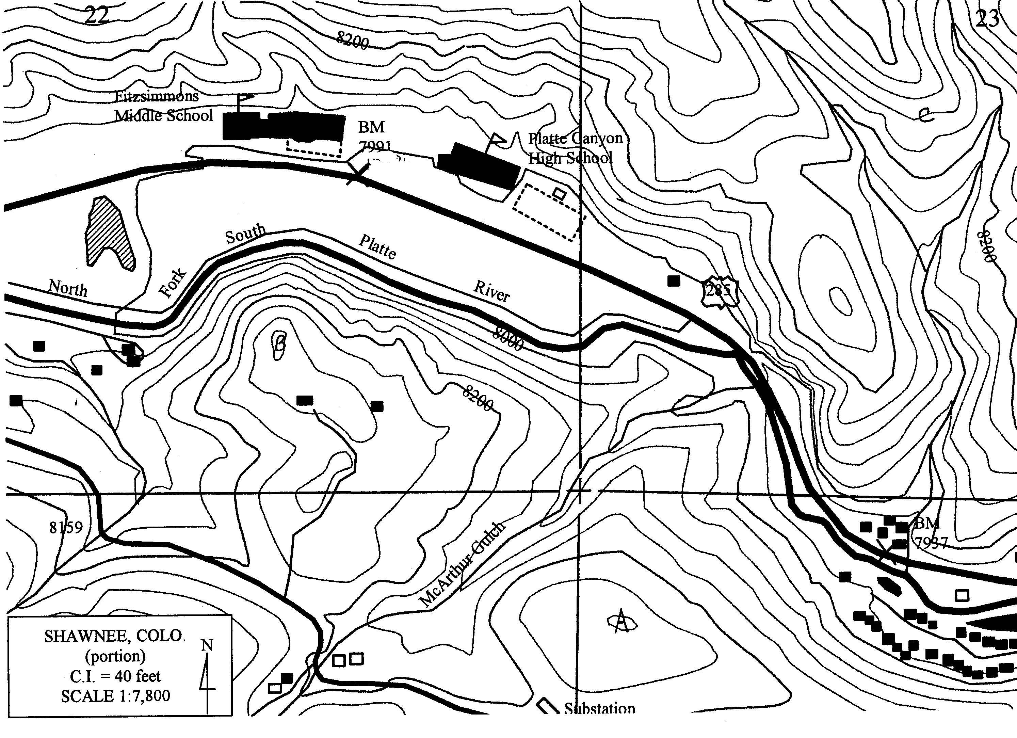
19 | What is the contour interval on this map? | a. 40 meters  b. 40 feet  c. 1:7800  d. not indicated  e. 7991’
20 | What is the dashed rectangle located to the east of the old high school? | a. parking lot  b. football field  c. cemetery  d. temporary storage building  e. proposed building site  f. none of the above
21 | What is the elevation of the benchmark between the two schools? | a. 7800’  b. 7991’  c. 8100’  d. 8200’  e. 8291’  f. none of the above
22 | What section is PCHS and FMS located in? | a. 21  b. 22  c. 23  d. 24  e. 25  f. none of the above
23 | What is the arrowhead shaped object southwest of FMS between 285 and the South Platte River? | a. an future athletic area  b. a permanent lake  c. an intermittent lake  d. a dump pile of gravel  e. soccer field  f. none of the above
24 | According to the map, what is the approximate elevation of the front of the new high school? | a. 7900’  b. 8000’  c. 8100’  d. 8200’  e. 8300’
25 | What is the elevation of the point marked with the letter C? (NE part of the map). | a. 8280’  b. 8320’  c. 8360’  d. 8400’  e. 8440’
26 | A location whose latitude is 90° N is located on the | a. North Pole  b. Arctic Circle  c. equator  d. Antarctic circle  e. South Pole
27 | The angle in degrees east and west of the Prime Meridian is | a. latitude  b. longitude  c. declination  d. inclination  e. none of the above
28 | A compass needle points toward the | a. geographic north pole  b. geographic south pole  c. geomagnetic north pole  d. geomagnetic south pole  e. none of the above
29 | The relationship between a distance on the Earth and the distance on a map is called | a. elevation  b. altitude  c. contour interval  d. scale
30 | On a topographic map, elevation is shown by | a. scale  b. contour lines  c. colors  d. both a & c  e. both b & c
31 | One degree of latitude equals | a. 1/60th of the Earth’s  circumference  b. 1/90th of the Earth’s  circumference  c. 1/180th of the Earth’s  circumference  d. 1/360th of the Earth’s  circumference  e. depends on how close it is  to the pole
32 | During the northern hemisphere’s summer, the sun’s rays are pointing directly down on the | a. Arctic Circle  b. Denver  c. Tropic of Cancer  d. Equator  e. Tropic of Capricorn  f. North Pole
33 | During the northern hemisphere’s winter, the sun’s rays are pointing directly down on the | a. Arctic Circle  b. Denver  c. Tropic of Cancer  d. Equator  e. Tropic of Capricorn  f. South Pole
34 | If 1 inch on a map equals 2000 feet in real life, which of the following would be its scale? | a. 1:2000  b. 1:166  c. 1:24000  d. 1:240000  e. none of these
35 | If the Earth were not tilted with respect to the sun, which of the following would be true? | a. There would be 24 hours of  daylight for half the year  followed by 24 hours of  darkness.  b. There would be only one  season during a year  depending on where you  lived.  c. Each day would be exactly  12 hours of daylight and 12  hours of darkness.  d. Both a & c  e. Both b & c
36 | The Earth’s magnetic pole is the same as the Earth’s geographic pole | a. True  b. False
37 | The Earth’s geographic pole is the same as the Earth’s axis of rotation. | a. True  b. False
38 | The Earth’s axis is tilted how many degrees from its orbital plane? | a. 7.5 degrees  b. 20 degrees  c. 23.5 degrees  d. 40 degrees  e. 66.5 degrees
39 | A point at 23.5 degrees north latitude would lie on | a. Arctic Circle  b. Tropic of Cancer  c. Equator  d. Tropic of Capricorn  e. Antarctic Circle  f. Denver
40 | A point at 66.5 degrees south latitude would lie on | a. Arctic Circle  b. Tropic of Cancer  c. Equator  d. Tropic of Capricorn  e. Antarctic Circle  f. Sidney, Australia
41 | Concentric circles at right angles to the axis of the earth are called | a. great circles  b. parallels  c. meridians  d. tropics  e. none of these
42 | The Prime Meridian passes through an observatory in | a. London, England  b. Denver, Colorado  c. Paris, France  d. Greenwich, Connecticut  e. Greenwich, England  f. New York, New York
43. | Bailey’s approximate latitude and longitude are | a. 39° N and 105° W  b. 39° N and 105° E  c. 39° S and 105° W  d. 105° N and 39° W  e. none of these
44. | If the grid to the right represents a typical township, what section is black?  a. 10  b. 9  c. 14  d. 27  e. 20
45 | If the grid to the right represents a typical township, what section is black?  a. 2  b. 12  c. 7  d. 5  e. none of these
46 | 7.5 minutes can also be written as | a. 7’ 50”  b. 7° 5’  c. 7’ 30”  d. 7’ 5”  e. 75”  f. none of these
47 | 3.25 degrees can also be written as | a. 325’  b. 3° 25’  c. 3° 25”  d. 3° 15’  e. 3° 15”
48 | During the southern hemisphere’s summer, the sun’s rays are pointing directly down on the | a. Arctic Circle  b. Denver  c. Tropic of Cancer  d. Equator  e. Tropic of Capricorn
49 | If 1 inch on a map equals 2000 feet in real life, which of the following would be its scale? | a. 1:2000  b. 1:166  c. 1:24000  d. 1:240000  e. none of these
50 | A point at 66.5 degrees south latitude would lie on | a. Arctic Circle  b. Tropic of Cancer  c. Equator  d. Tropic of Capricorn  e. Antarctic Circle
51 | What is the approximate latitude and longitude of the + sign on the grid to the right?  a. 15° N and 5° W  b. 15° N and 5° E  c. 5° N and 15° W  d. 5° S and 15° E  e. 5° S and 15° W | 30 20 10 0 10 20  20  10  0  10  20
52 | The geomagnetic north pole is located | a. at the geographic north pole  b. Denver  c. somewhere in northeastern Canada  d. in southern England near Greenwich  e. in Nome, Alaska
53 | The four main subdivisions of Earth Science are geology, meteorology, astronomy, and … | a. paleontology  b. ecology  c. hydrology  d. oceanography  e. geomorphology
54 | If you were standing at the geomagnetic north pole, which direction would your compass needle point if it were free to move in any direction? | a. it would spin around in a circle  b. it would point north toward the north pole  c. it would point straight up  d. it would point straight down  e. it wouldn’t point in any  direction because it wouldn’t work
55 | You now move to the geographic North Pole. Which way would the needle of a normal compass point? | a. it would spin around in a circle  b. it would point north  c. it would point south  d. it would point in some eastwardly direction  e. it wouldn’t point in any direction because it  wouldn’t work
56 | From where you are sitting in the classroom, which way is approximately north? | a. toward the windows  b. toward the hallway  c. toward the front of the room (gray board)  d. toward the back of the room (lab benches)
57 | You are planning to take a hike. You have a choice as to three different paths to follow. Along Path A, the contour lines are closely spaced together. Along Path B, they are generally widely spaced but occasionally they are so close together that they almost touch. Patch C has mostly widely spaced lines. Which path would you take to have the least strenuous walk. | a. Path A  b. Path B  c. Path C  d. Either A or B, they are fairly similar  e. Cannot tell from the information given
58 | The use of the word “theory” is quite different when applied to scientific ideas compared to the way it is used in everyday life. Which of the following would be the best definition of the word “theory” as used by a scientist. | a. a theory is essentially equivalent to a scientific hypothesis  b. a theory is an answer based on what you think is happening to explain what you observe  c. a theory is an idea or explanation of a set of ideas that is based on numerous facts that have never been disproved.  d. a theory is an answer based on faith  e. none of the above is a suitable definition of a scientific theory
59 | Meteorology is one of the basic units included within Earth Science. Literally, the word would translate as “the study of meteors”. How can this word be applied to the study of weather and climate? | a. the word meteor in Latin really translates into English as weather  b. the word meteor was originally applied to anything falling through or in the atmosphere  c. it cannot be applied to the study of weather and climate, it really means “the study of meteors or meteorites”  d. none of the above explanations are accurate
60 | The relationship between a distance on the Earth and the distance on a map is called | a. elevation  b. altitude  c. contour interval  d. scale  e. degrees
61 | The shortest day of the year occurs during which of the following? | a. vernal equinox  b. summer solstice  c. autumnal equinox  d. winter solstice  e. none of the above
62 | During the summer solstice, the sun at midday will be directly overhead in Bailey. | a. True  b. False
63 | During the month of June at a latitude of 80 degrees North and a longitude of 150 degrees West, approximately when will the sun rise above the horizon during the morning. | a. about 7:00 AM  b. about noon  c. it never will rise  d. it will never set therefore it cannot rise  e. cannot tell from the information given
64 | Which one of the following phrases is true of the tilt of the Earth’s axis? | a. It remains constant throughout the year.  b. It remains parallel to the plane of its orbit.  c. It changes with the seasons.  d. It is perpendicular to the plane of its orbit.
65 | Which of the following is most likely the result from an increase in the earth’s rotation rate? | a. an increase in the length of a day  b. an increase in the length of a year.  c. a decrease in the length of a day  d. a decrease in the length of a year
66. | The boundary between the earth’s crust and mantle where the speed of seismic waves changes is called the | a. Moho  b. shadow zone  c. magnetosphere  d. hydrosphere
67. | If there were no moon, there would be no tides. | a. true  b. false
68. | What is the maximum number of high tides on Earth during a twenty-four hour period? | a. 1  b. 2  c. 3  d. 4
69. | How many minutes in a degree? | a. 30  b. 60  c. 180  d. 360
70. | A rancher tells you he owns a half section of land. Which of the following best describes how much land he owns? | a. 640 acres  b. 1 square mile  c. 1 mile square  d. 320 acres  e. 18 square miles
71 | The prefix “topo” used in the word “topographic” means which of the following? | a. elevation  b. shape  c. gradient  d. contour line  e. map
72 | Finish the following phrase.  Contour Lines never ______________. | a. end  b. run perfectly north and south  c. cross  d. lie on top of each other
73 | The G in GMT stands for which of the following? | a. General  b. Geographic  c. Geologic  d. Greenwich  e. Greenland
74 | A magnetic compass will point too far east, directly at, or too far west of the geographic north pole here in Bailey? | a. too far east  b. directly at  c. too far west  d. none of these
75 | Reasoning that starts out with one fact the leds to numerous theorems based on the original fact is called … | a. inference  b. inductive  c. deductive  d. guessing  e. hypothesizing
76 | Reasoning starting out with lots of observations that lead to a theory is called … | a. inference  b. inductive  c. deductive  d. guessing  e. hypothesizing

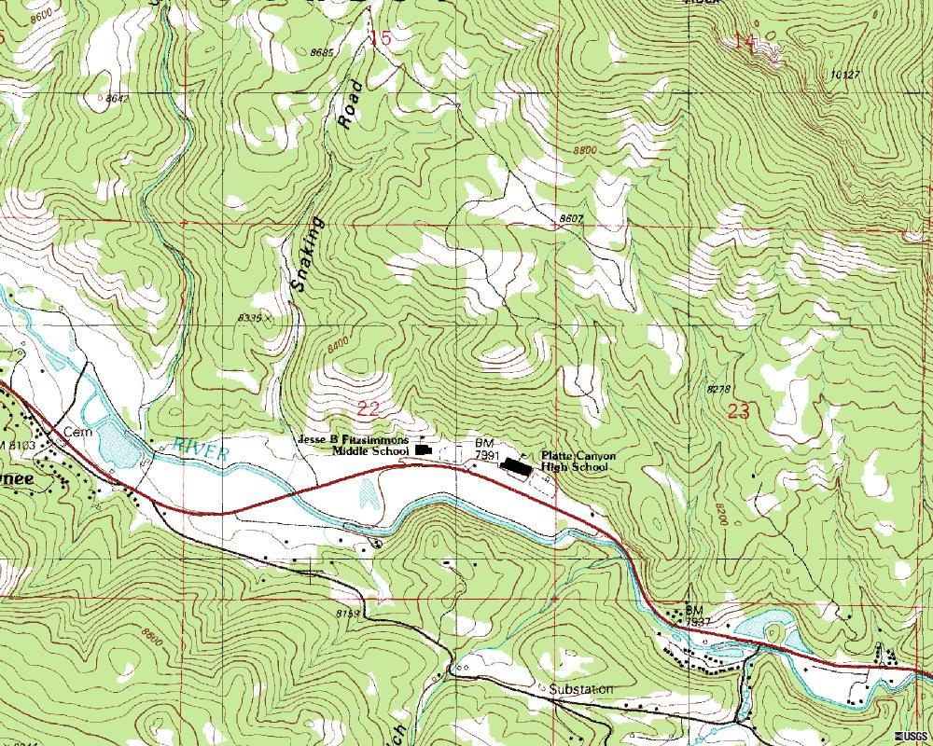
105° 33’
105° 31’
39°
25’
39°
26’

77. | Using the above map, what would be the best approximation for the latitude for Platte Canyon High School? | a. 39º 25’ 45”  b. 39º 25’ 30”  c. 39º 25’ 15”  d. 39º 25’ 00”  e. 105º 32’
78 | Using the above map, what would be the best approximation for the latitude for the substation? | a. 39º 24’ 45”  b. 39º 24’ 30”  c. 39º 25’ 15”  d. 39º 25’ 00”  e. 105º 32’
79 | Which of the following latitude and longitudes is closest to the cemetery in Shawnee? | a. 39º 25’ 15” 105º 32’ 20”  b. 39º 25’ 00” 105º 33’ 00”  c. 39º 25’ 15” 105º 33’ 50”  d. 39º 25’ 15” 105º 33’ 20”  e. 39º 25’ 00” 105º 32’ 20”
80 | Which is higher in elevation on the above map, Shawnee or Platte Canyon High School? | a. Shawnee  b. Platte Canyon High School  c. No way to tell from the map  d. Actually they are the same elevation

R. 13 W. |  |  |  |  |  | R. 12 W. |  |  |  |  |  | R. 11 W
 |  |  |  |  |  |  |  |  |  |  |  |  |  |  |  |  |  | T. 1 N.
 |  |  |  |  |  |  |  |  |  |  |  |  |  | B |  |  |  | T. 1 N.
 |  |  | A |  |  |  |  |  |  |  |  |  |  |  |  |  |  | T. 1 N.
 | O |  |  |  |  |  |  |  |  |  |  |  |  | C |  |  |  | T. 1 N.
 |  |  |  |  |  |  |  |  |  |  |  |  |  |  |  |  |  | T. 1 S.
E |  |  |  |  |  |  |  | F |  |  |  | D |  |  |  |  |  | T. 1 S.
 |  |  | P |  |  |  |  |  |  |  |  |  |  |  |  |  |  | T. 1 S.
 |  |  |  |  |  | Q |  |  |  | R |  |  |  |  |  |  |  | T. 1 S.
 |  |  |  |  |  |  |  |  |  |  |  |  |  |  |  |  |  | T. 2 S.
 |  | G |  |  |  |  | S |  |  |  |  |  |  |  |  |  |  | T. 2 S.
 |  |  |  |  |  |  | T |  |  |  |  |  |  |  |  | U |  | T. 2 S.

81. | Using the above figure, the letter A is located in what township and range? | a. T. 1 N., R 13 W.  b. T. 1 S., R 13 W.  c. T. 2 S., R 13 W.  d. T. 1 N., R 12 W.  e. T. 2 S., R 11 W.
82 | Using the above figure, the letter B is located in what section? | a. 9  b. 10  c. 3, -1  d. NW ¼  e. NE ¼
83 | Using the above figure, the area shaded for letter R is best described by which of the following? | a. SE ¼ NW ¼  b. SW ¼ SE ¼  c. SE ¼ SW ¼  d. S ¼ W ¼  e. none of the above
84 | Using the above figure, the area shaded for letter O is best described by which of the following? | a. NW ¼ sec. 33  b. NW ¼ sec. 34  c. NE ¼ sec. 18  d. NW ¼ NW ¼  e. none of these
85 | The total area shown in the above figure is which of the following? | a. 3 miles x 3 miles  b. 6 miles x 6 miles  c. 18 miles x 18 miles  d. 5760 acres  e. none of the above

